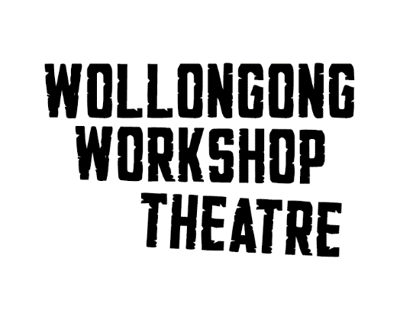
The Full Monty - Audition Pack – young performer
About the show
In 1997, a BAFTA-award-winning film took the world by storm. It told the story of six men, ex-steelworkers, thrown on the scrapheap of Thatcher’s Britain. Scrabbling to regain a sense of self-worth, they had nothing more to lose.
Now they're back. The Full Monty (NB. the play, not the musical) is by Simon Beaufoy (Oscar-winning writer of the film). This story is bold, vibrant, touching - and highly relevant to all of us entering an AI age…
We’re searching for a young performer (playing age 12 to 16)
We’re looking for a young actor or actress to play the role of Nathan / Nate. The role is originally written for a male actor aged between 10 and 12, but we would be willing to consider an older performer with a playing age (appears to be) under 16, even if they are over 16 years old.
We will be holding Saturday auditions at Workshop Theatre 190 Gipps Road, Gwynneville, which is just behind the Senior Citizens Centre. Sign up for an audition time is
https://signup.com/go/gHuTNDX
Audition will take the form of a short scene of dialogue and a chilled out chat with the director.
Schedule
Please let us know of planned unavailability during the rehearsal period Sept to October: |  | You must be available in November, 2025:
 |  | Tech week | 1^{st,} 2nd 3rd, 4^{th,} 5th
Audition dates | 16 and 23 Aug | Weekend 1 | 7th 8th evenings  9th matinee
Rehearsals (1900 to 2000)  tbc as needed but max one night a week for Nathan! | From 1st September  Mon/Wed/Thurs | Weekend 2 | 14th 15th evenings  16th matinee
Bump In & Media | 4th & 5th October | Weekend 3 | 21st 22nd evenings  23rd bump out

Parents of under 16s, please note:
The script includes a final scene which briefly requires male nudity from some adult performers. The young actor will not be onstage at this point.
The director and stage manager are female, mothers and have Working With Children Checks. Under 16 year olds would be welcome to bring a chaperone. All performers and crew also have WWC checks.
If there are questions, we would be pleased to answer these.
Kind regards,
Anna Thomas (Director) and Tessa Parsons (Production Manager / SM)

AUDITION PACK – END OF DOCUMENT

